🚀 Jenkins Installation on AWS EC2 (Ubuntu)
Deployed and configured Jenkins CI/CD server on an AWS EC2 Ubuntu instance.
Set up environment by installing Java (OpenJDK 21), configured Jenkins, and enabled port 8080 for external web access. Managed security group inbound rules to ensure secure connectivity.
Skills demonstrated:
☁️ AWS EC2 • 🧩 Jenkins • 🔐 Security Groups • ☕ Java • ⚙️ Linux Commands • 🌐 Port Management
Result: Successfully accessed Jenkins through a public endpoint and verified continuous integration setup.

Step 1: Create an EC2 Instance
- Launch an **EC2 instance** using the **Ubuntu** AMI (e.g., Ubuntu 22.04 LTS).
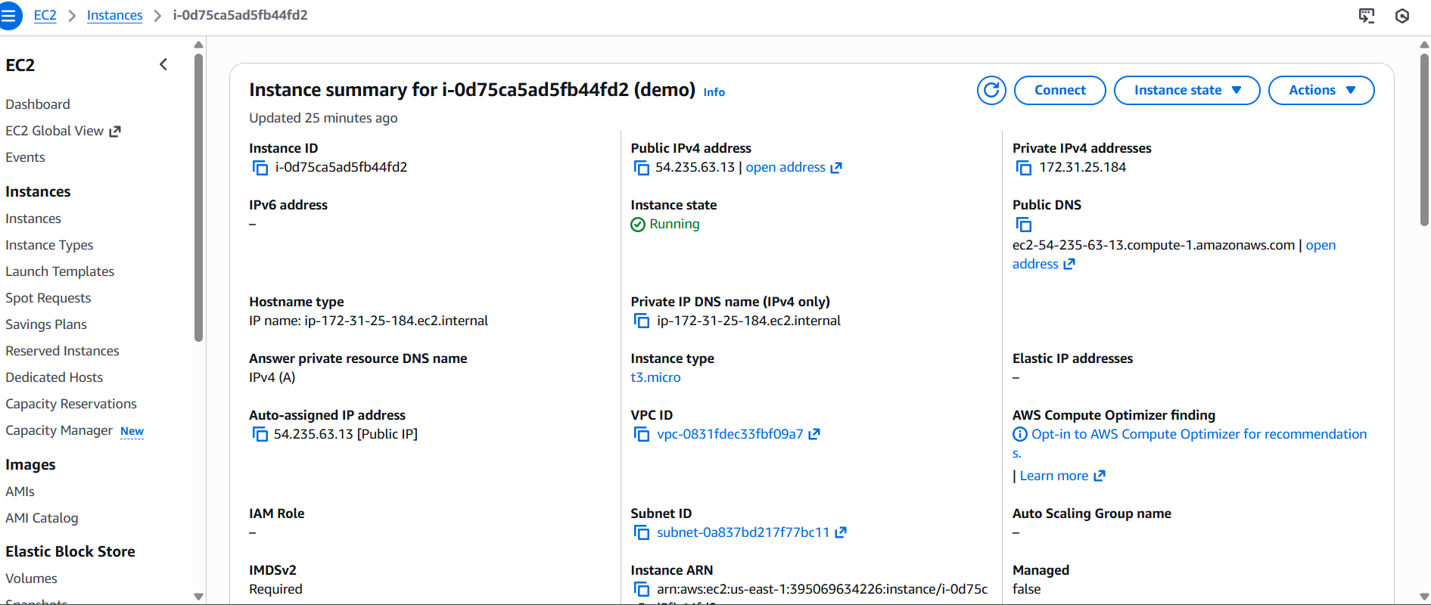
- Choose an appropriate instance type (e.g., `t2.micro` for testing).
- Create or select an existing **key pair** (.pem file) for SSH access.
Step 2: Connect to the Instance via SSH
From your terminal (Linux/Mac) or PowerShell (Windows), connect using:
Bash
ssh -i "your-key.pem" ubuntu@<public-ip-address>
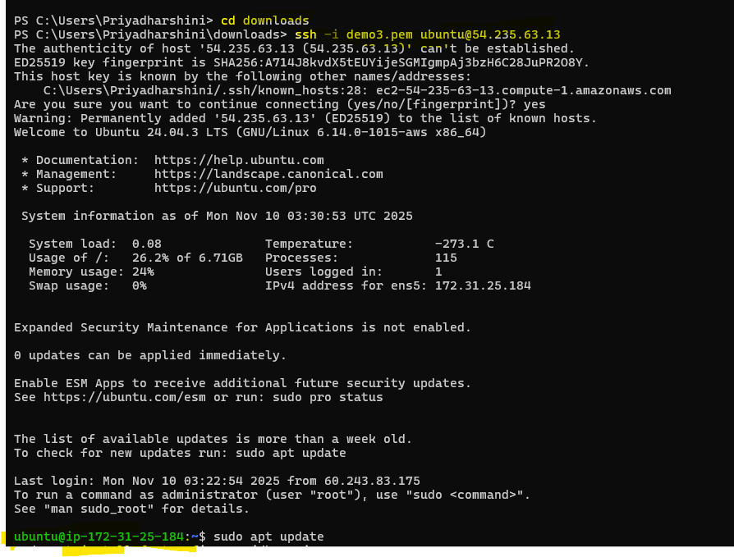
Step 3: Install Java
Jenkins requires Java to run. Update your packages and install Java.
sudo apt update
sudo apt install openjdk -21-jre
Verify the installation:
java -version
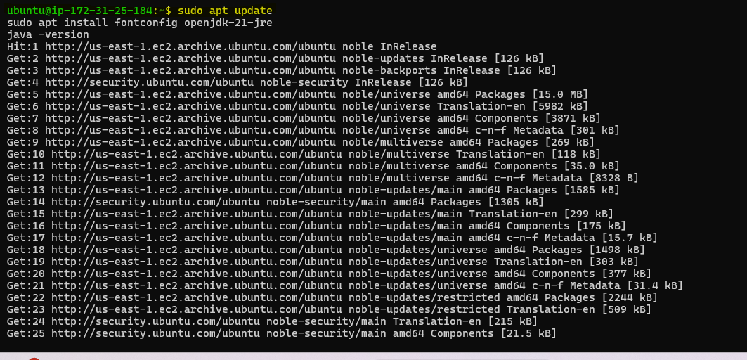
Step 4: Install Jenkins
Add the Jenkins repository and install it:
sudo wget -O /etc/apt/keyrings/jenkins-keyring.asc \
https://pkg.jenkins.io/debian/jenkins.io-2023.key
echo "deb [signed-by=/etc/apt/keyrings/jenkins-keyring.asc]" \
https://pkg.jenkins.io/debian binary/ | sudo tee \
/etc/apt/sources.list.d/jenkins.list > /dev/null
sudo apt update
sudo apt install Jenkins
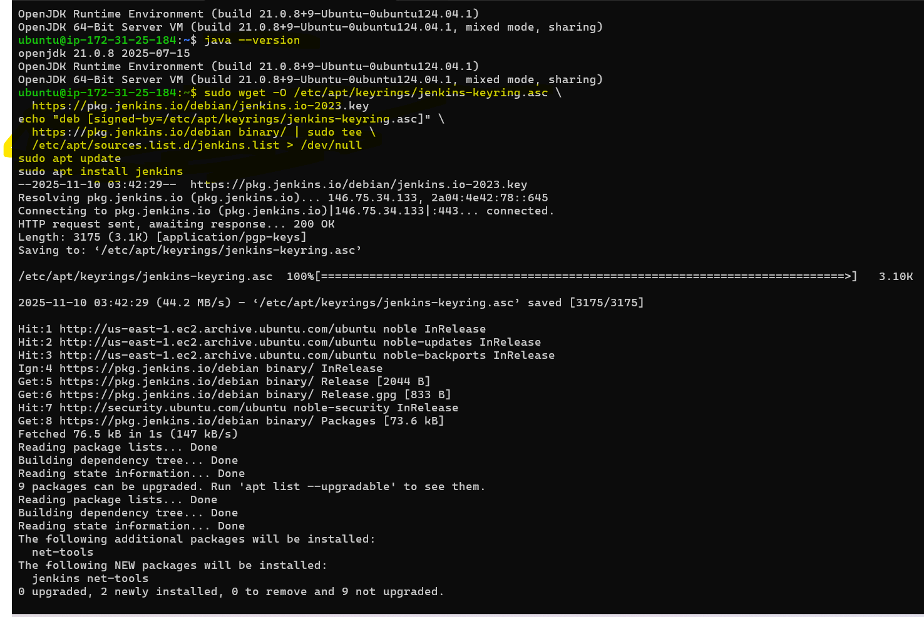

Step 5: Open Port 8080 for Jenkins
In your EC2 Security Group:
- Edit Inbound Rules → Add Rule
  - Type: Custom TCP
  - Port Range: 8080
  - Source: 0.0.0.0/0 (for public access) or your IP (for restricted access)
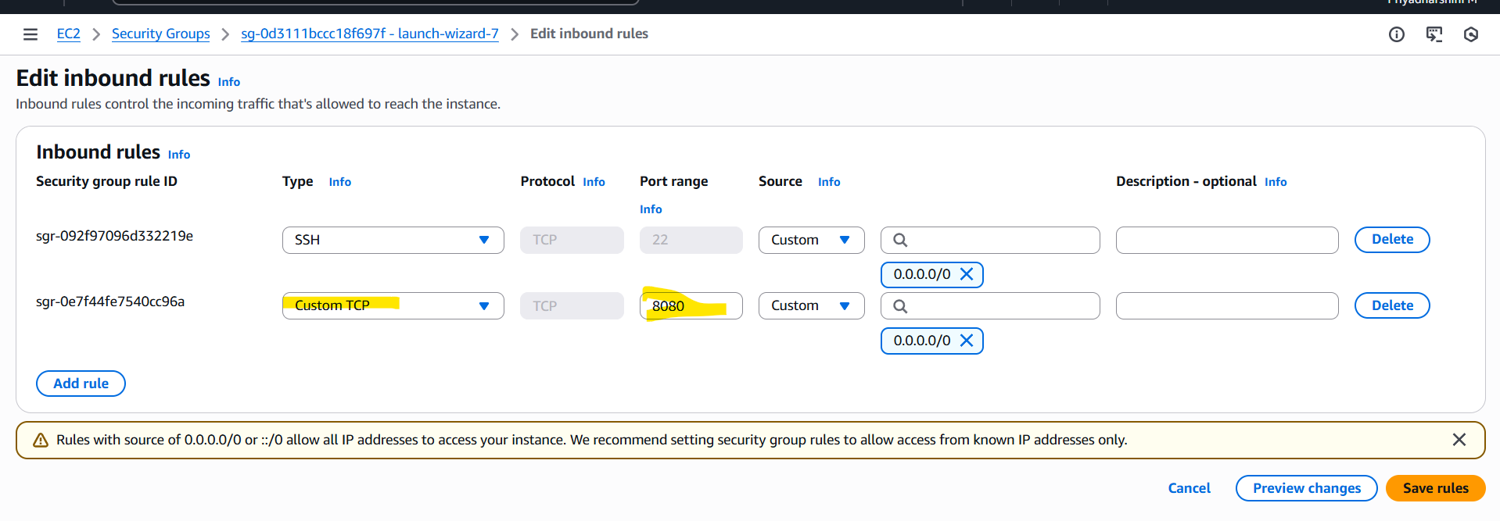
Step 6: Access Jenkins Web Interface
Now, open your browser and visit:
http://<your-public-ip>:8080
